

**DESIGN DOCUMENT**

**College Admission Predictor**

**Team Members:**

Alavala Pushpalatha

Meghana Yarramreddy

Naga Sravya Gudipati

Shreenidhi Rai N G

Dheeraj Kumar Gundoji

Kommi Mahesh

**ACTIVITY DIAGRAM OF COLLEGE ADMISSION PREDICTOR:**

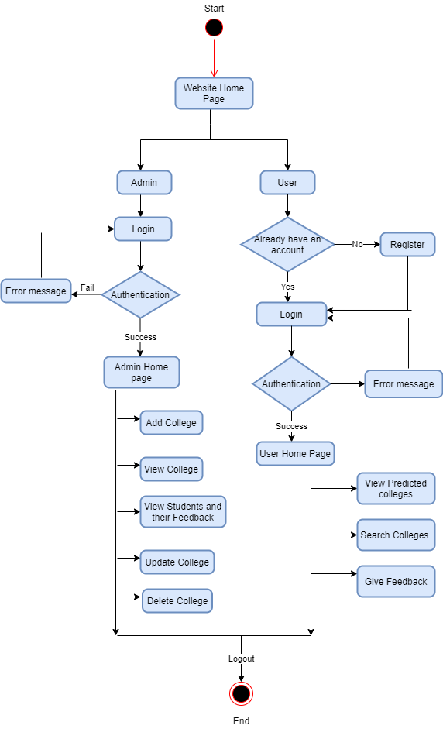

**USE CASE DIAGRAM:**

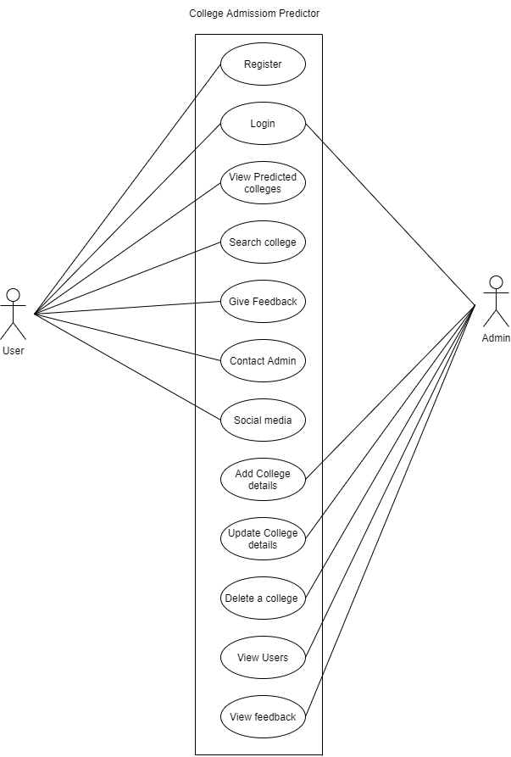

**SEQUENCE DIAGRAMS OF COLLEGE ADMISSION PREDICTOR:**

* Sequence Diagram of Registration system:

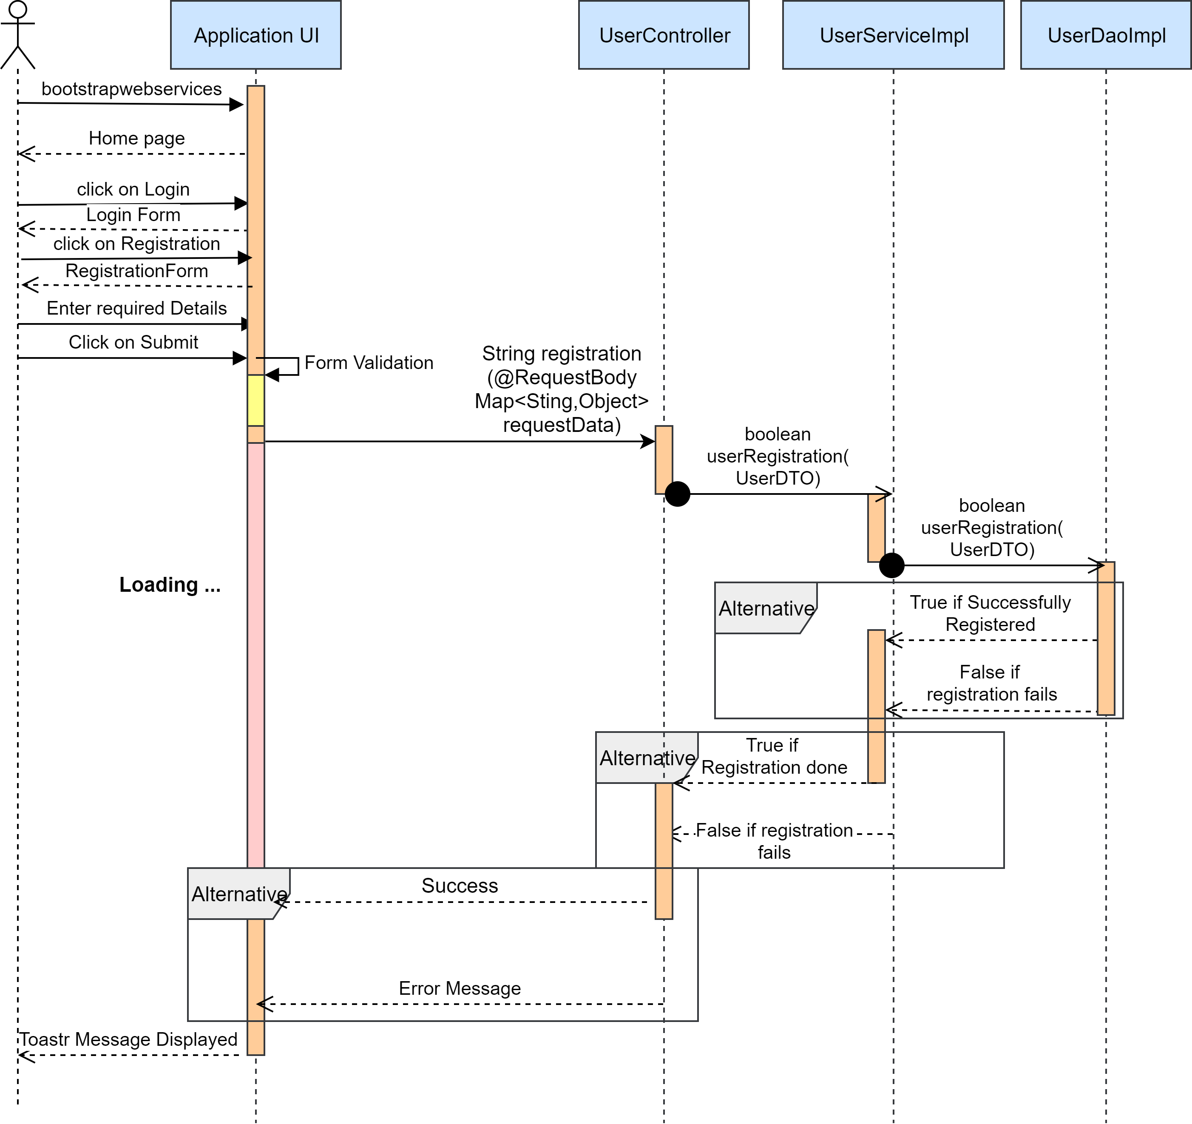

* Sequence Diagram of Login System:

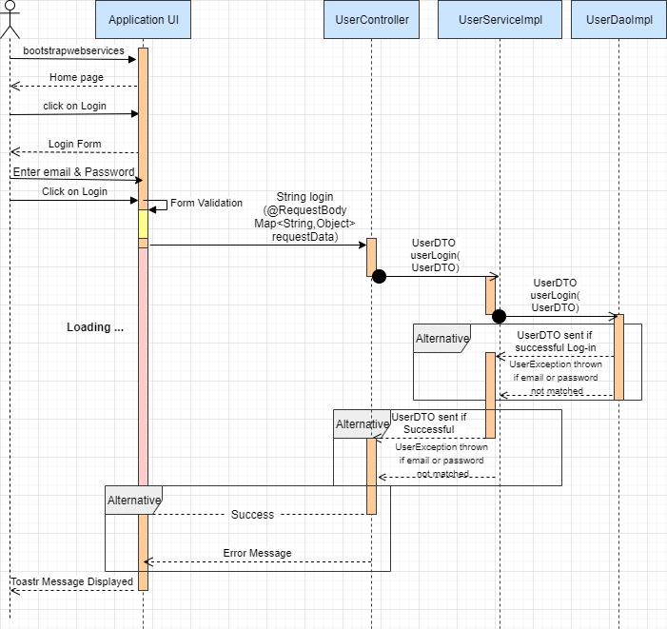

* Sequence Diagram of Logout:

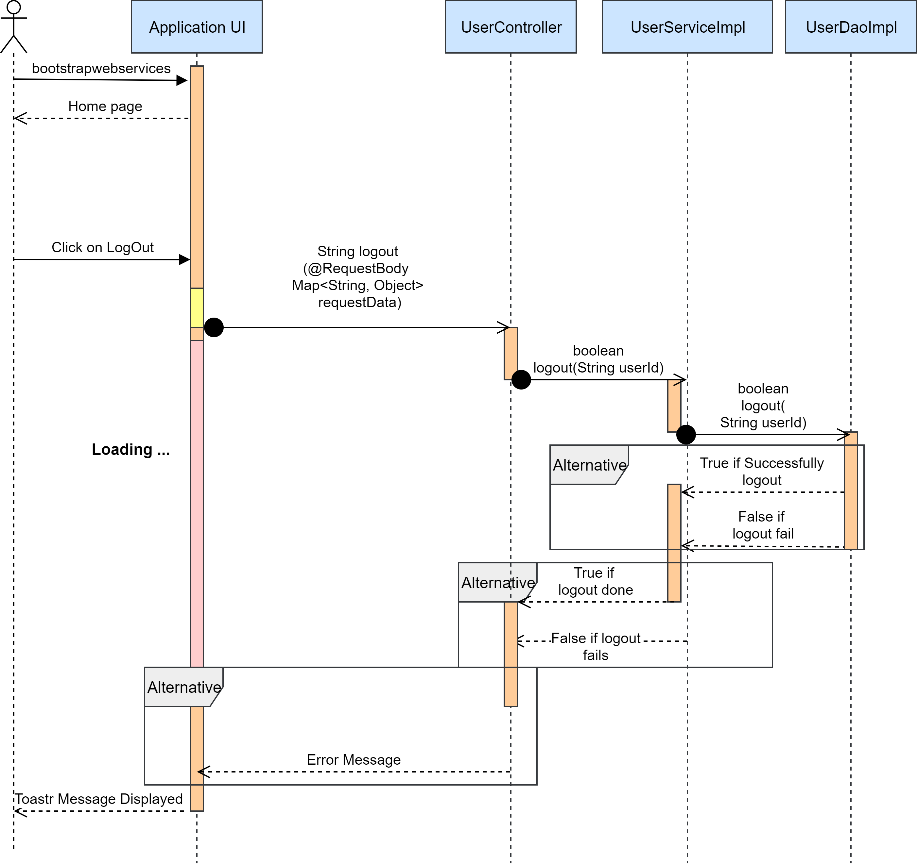

* Sequence Diagram of College exploration system:

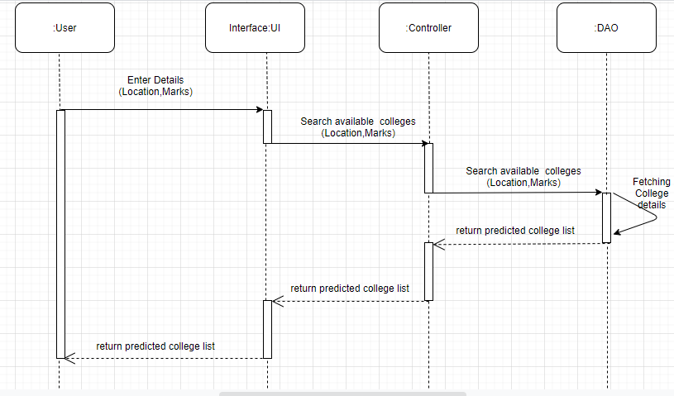

* Sequence Diagram of College Adding system:

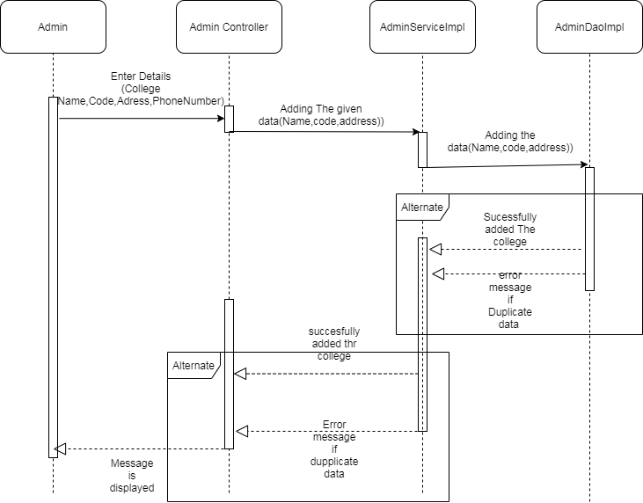

**Flow Diagram of College Admission Predictor:**

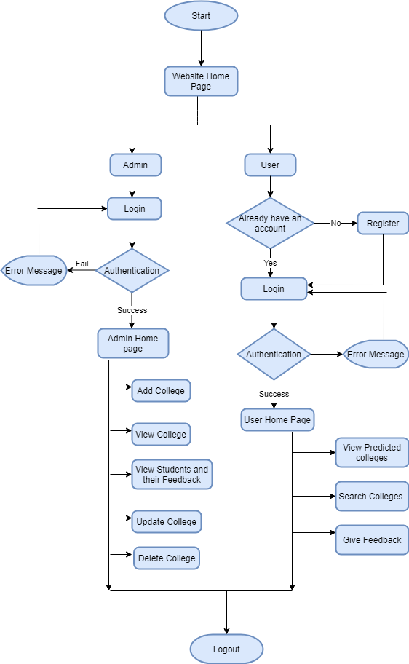**CLASS DIAGRAM OF COLLEGE ADMISSION PREDICTOR :**

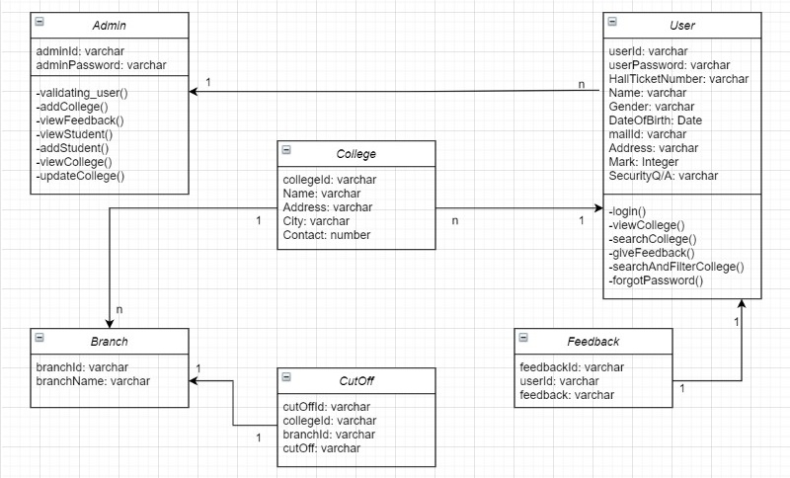

**ENTITY RELATIONSHIP DIAGRAM:**

* **ER DIAGRAM OF COLLEGE DATABASE:**

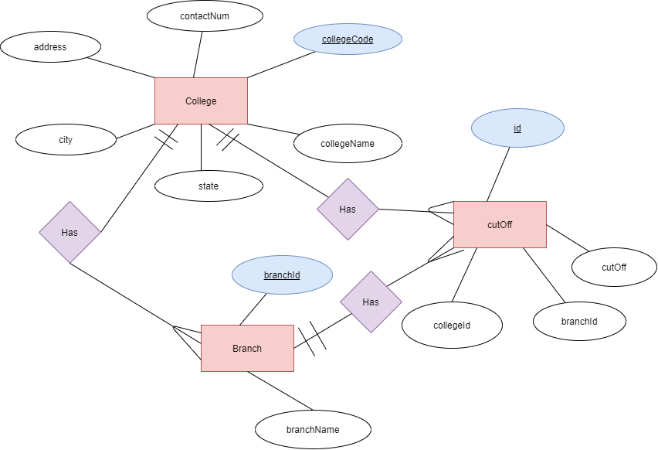

* **ER DIAGRAM OF USER DATABASE:**

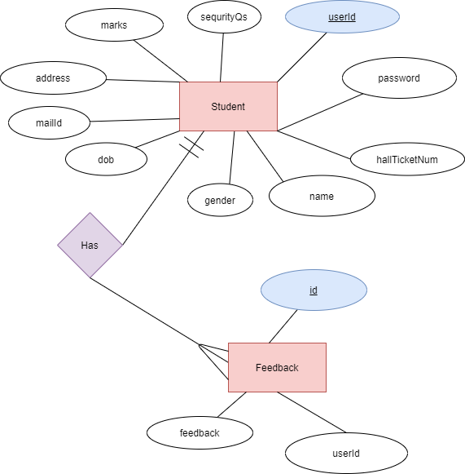

**Wireframes:**

* **User Sign Up:**

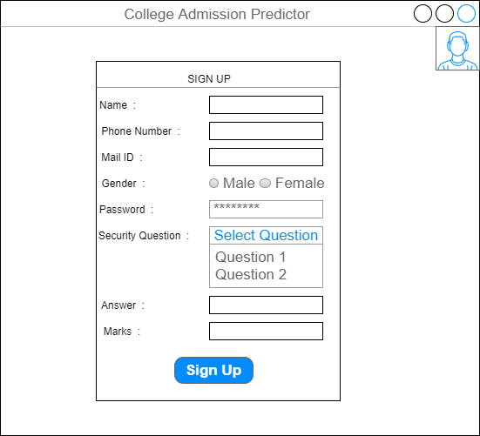

* **User Sign In:**

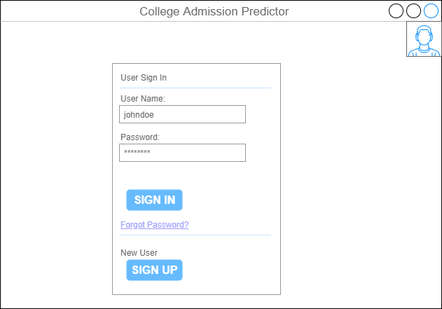

* **Admin Sign In:**

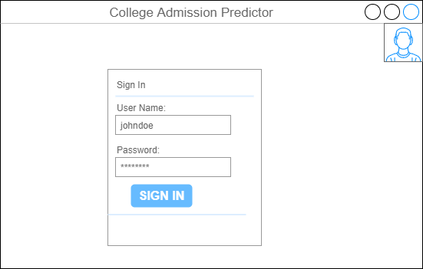

* **Add College:**

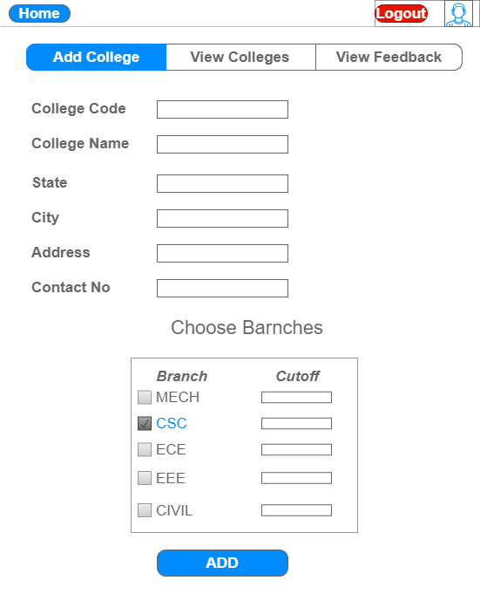

* **View Colleges:**

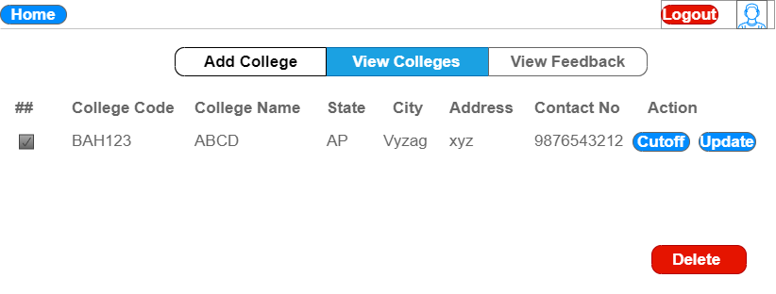

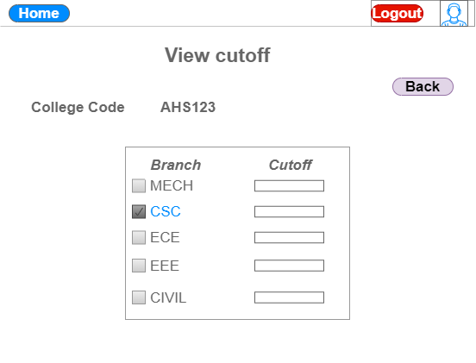

* **Update College Details:**

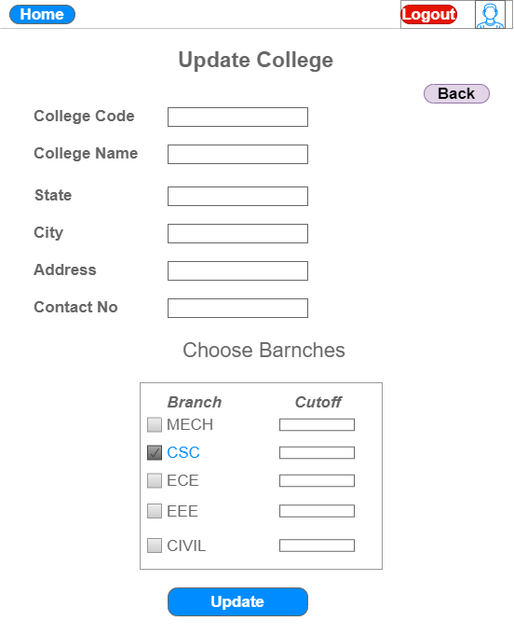

* **View Students/Users:**

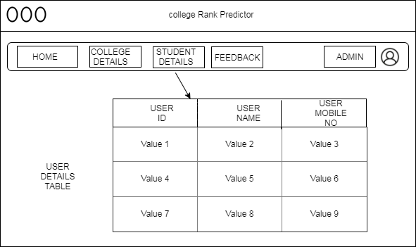

* **View Feedback:**

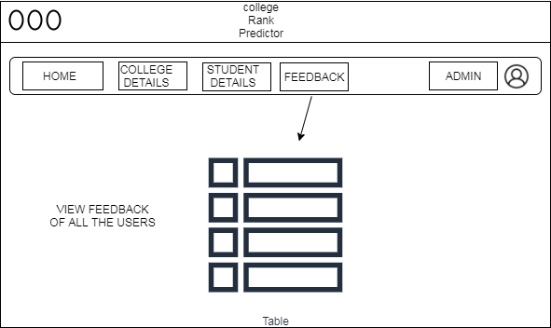

* **Student View Predicted Colleges:**

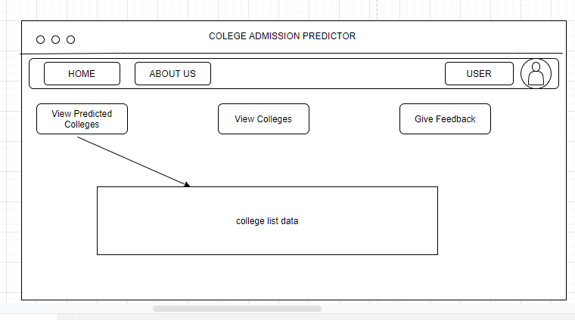

* **Search colleges:**

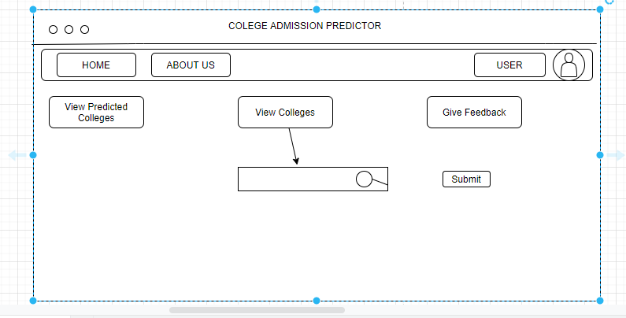

* **Give Feedback:**

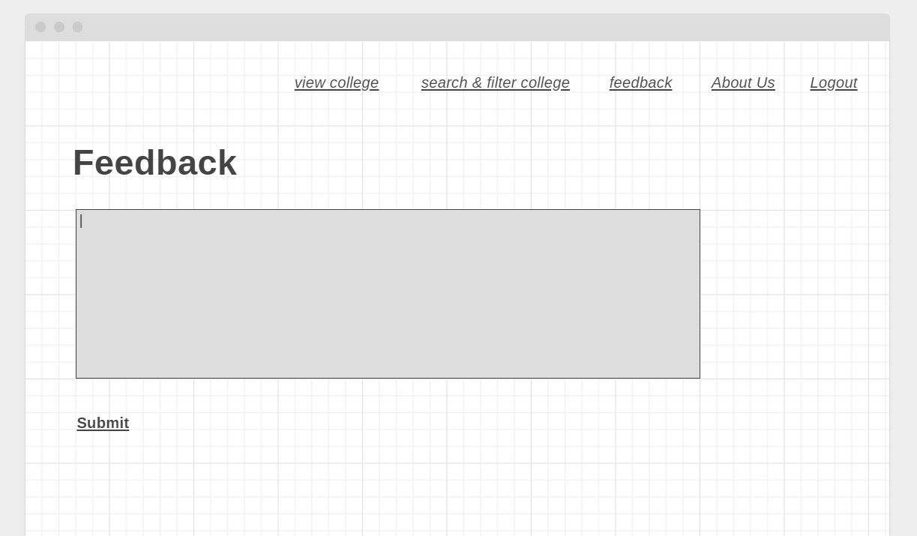

* **About Us:**

